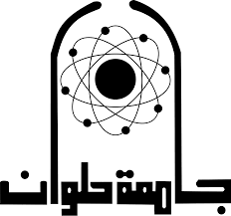

**Project idea 14**

**An Automated Optical Character Recognition of Handwritten English Letters using Artificial Neural Networks.**

|  |  |
| --- | --- |
| **Student name** | **Student ID** |
| Mahran saber | **202000954** |
| Mohamed yasser | **202000831** |
| Omar ashraf | **202000589** |
| Mostafa tarek | **202000901** |
| Nada maher | **202000993** |
| Merna ehab | **202000968** |

Code & Report Shared Folder URL **[shorturl.at/mnvyB](https://drive.google.com/drive/folders/1cKiKVuegDdukgPwZZpXrFPeo0zDU8IOZ?usp=sharing)**

**Contents**

**1-*Introduction and overview***

***1.1 Project idea in details***

: An Automated Optical Character Recognition of Handwritten English Letters using Artificial Neural Networks

Optical character recognition, often abbreviated as OCR, plays an enormous part in the text recognition software many of us rely on today through Adobe Acrobat, Google Drive, and the like.

While most would assume that the ability to recognize and translate an image to text would be a modern-day invention based on some contemporary algorithm, the truth is that OCR software and picture-to-text technology have been around since at least the late 1920s.

The man responsible for one of the earliest OCR innovations?

An Austrian engineer named Gustav Tauschek. He’s the one who patented an optical character recognition device in Germany in 1929 and again in the United States in 1935.

But how did Gustav Tauschek come up with such a novel idea for software? And how did it work with such archaic software at the time? Not to mention, what is the historical significance of Tauschek’s text recognition software?

Thankfully, each of these questions has an answer. Read on to learn more about Gustav Tauschek and his OCR invention.

Created : 1929

Creator : Gustav Tauschek

Original Use : Text recognition

Cost : N/A

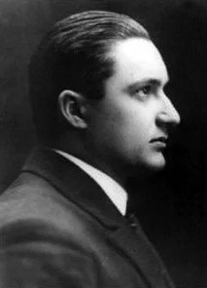

Black and white portrait of Gustav Tauschek.

Key Points about Optical Character Recognition (OCR)

The earliest forms of OCR image to text devices were conceived in the late 1800s for use with the blind. Inventors hoped that their rudimentary picture to text software could help the blind to read.

In the 1970s, American inventor Ray Kurzweil created Kurzweil Computer Products Inc. — a company that took serious inspiration from Gustav Tauschek’s device in the creation of its omni-font OCR software.

Remarkably, Ray Kurzweil’s algorithm was capable of recognizing practically any text font.

In addition to his groundbreaking image to text invention, Gustav Tauschek developed 169 patents and sold them all to IBM. Given a five-year contract by the software giant, Tauschek used OCR technology to develop a punchcard-based accounting system and several other OCR-reliant, punchcard-based machines.

**Optical Character Recognition (OCR) History**

Viennese engineer Gustav Tauschek was something of a self-taught genius during his time in the early 20th century. With over 200 patents to his name — including the aforementioned 169 sold to IBM — Tauschek was undoubtedly a software mastermind capable of creations far ahead of what was being invented by his contemporaries at the time. Throughout his career, he worked for both IBM and the German arms and automotive manufacturing company Rheinische Metallwaren- und Maschinenfabrik (known as Rheinmetall today).

Tauschek’s work with optical character recognition began with the mission to create software capable of transforming pictures to text with accuracy and efficiency. His main use for this proprietary technology was in his punchcard-based calculating machines. From there, Tauschek invented the Reading Machine of Tauschek: a mechanical device that could read characters and numerals on an image and transform them into printed characters and numbers on a piece of paper.

Many before Tauschek’s time — such as American inventor Charles R. Carey — had come up with similar, earlier forms of the OCR, but Tauschek was the first to take it off the page and turn it into a real-world device with his Reading Machine.

The patent drawing of the Reading Machine of Tauschek.

**Optical Character Recognition (OCR): How It Worked**

Gustav Tauschek’s Reading Machine was a mechanical device that used a template that matched with a photoelectric photodetector. As a picture with text passed in front of the reading machine’s eye-like window, the comparison device — a disk with holes in the shape of letters and numbers — rotated in front of the window in search of a fit. When text on the image matched up with one of the letter-shaped holes on the comparison device, the machine rotated the printing drum to the corresponding letter. Then, the letter was printed onto a piece of paper.

From this time in 1929 through to the modern-day, the OCR device went through all sorts of different changes to meet all sorts of different needs (which will be touched on below). At the end of the day, though, the same basic concept remains integral to the development of OCR devices: the transformation of text on an image into machine-encoded text.

**Optical Character Recognition (OCR): Historical Significance**

After Tauschek’s novel invention, many other inventors and engineers took his ideas and extrapolated them in all sorts of different notable directions. This is, without question, the most historically significant thing about the OCR: the sheer number of different uses for Tauschek’s creation that came in the decades after.

In 1931, OCR technology was used in the creation of a text-to-telegraph device. From there, in 1951, this tech transformed into a text-to-Morse Code device. Then, in 1966, the technology became capable of reading handwriting and transforming it into text. In 1978, Ray Kurzweil’s Omni-font OCR came into existence. Then, in the ‘80s, OCR technology became an integral part of barcode scanners in retail stores and Xerox machines in offices and schools. Today, Google Drive and Adobe Acrobat offer free, online versions of OCR software capable of working in over 200 different languages with accuracy and clarity.

Clearly, from Gustav Tauschek to Ray Kurzweil to Google Drive and everyone in between, the OCR algorithm has major historical significance that continues to be innovated and improved still today.

Here**, the goal of a character recognition system** is to transform

hand written text document on paper into a digital format that

can be manipulated by word processor software. The system is

required to identify a given input character form by mapping it

to a single character in a given character set. Each hand written

character is split into a number of segments (depending on the

complexity of the alphabet involved) and each segment is

handled by a set of purpose built neural network. The final

output is unified via a lookup table. Neural network architecture

is designed for different values of the network parameters like

the number of layers, number of neurons in each layer, the initial

values of weights, the training coefficient and the tolerance of

the correctness. The optimal selection of these network

parameters certainly depends on the complexity of the alphabet

In this machine learning project, we will recognize handwritten characters, i.e, English alphabets from A-Z. This we are going to achieve by modeling a neural network that will have to be trained over a dataset containing images of alphabets.

***1.2 A Literature Review of Academic publications relevant to the problem***

**No.1:**

**Abstract:**

- In the present paper, we are use the neural network to recognize the character. In this paper it is developed 0ff-line strategies for the isolated handwritten English character (A TO Z) and (0 to 9) .This method improves the character recognition method. Preprocessing of the Character is used binarization, thresolding and segmentation method .The proposed method is based on the use of feed forward back propagation method to classify the characters. The ANN is trained using the Back Propagation algorithm. In the proposed system, English nue-merical letter is represented by binary numbers that are used as input then they are fed to an ANN. Neural network followed by the Back Propagation Algorithm which compromises Training.

**I.INTRODUCTION**

Handwriting recognition is undoubtedly one of the most challenging areas of pattern recognition. It is extremely useful in a wide range of real world practical problems, including documentation analysis, mailing address interpretation, bank check processing, signature verification, document verification and many others [1].Several pattern recognition approaches have been applied to both online and off-line handwriting recognition, including statistical methods, structural and syntactic methods, and neural networks. Some reading systems identify strokes; others try to identify Characters, groups of characters, or entire words . Neural networks are composed of simple elements operating in parallel. These elements are inspired by biological nervous systems. As in nature, the network Function is determined largely by the connections between elements. We can train a neural network to perform a particular function by adjusting the values Of the connections (weights) between elements. Commonly neural networks are adjusted, or trained, so that a particular input leads to a specific target output. Such a situation is shown below. There, the Network is adjusted, based on a comparison of the output and the target, until the network output matches the target. Typically many such input/target

pairs are used, in this supervised learning, to train a network. Computerized document processing has been growing rapidly since the 1980’s because of the exponentially increasing amount of daily received documents and the more powerful and affordable computer systems. Intuitively, the conversion of textual blocks into ASCII codes represents one of the most important tasks in document processing [5]. Our strategy of reclassifying characters is to incorporate typographical structure analysis which categorizes characters in the first step, and therefore it reduces the scope of character Recognition. Automatic Postal sorting, automatic bank cheque processing are application of Character recognition. In the work on character recognition has been reviewed. Optical Character Recognition (OCR) is used to recognize printed and handwritten characters. There are numerous approaches that address the problem and they vary in the features extracted from the graphical representation of the Characters.

**No.2**

**Abstract**

In the present paper, we are use the neural network to recognize the character. In this paper it is developed 0ff-line strategies for the isolated handwritten English character (A TO Z) and (0 to 9) .This method improves the character recognition method. Preprocessing of the Character is used binarization, thresolding and segmentation method .The proposed method is based on the use of feed forward back propagation method to classify the characters. The ANN is trained using the Back Propagation algorithm. In the proposed system, English nue-merical letter is represented by binary numbers that are used as input then they are fed to an ANN. Neural network followed by the Back Propagation Algorithm which compromises Training. Index Terms—Neural network, back propagation method Segmentation, image processing toolbox ,matlab

**I.INTRODUCTION**

Handwriting recognition is undoubtedly one of the most challenging areas of pattern recognition. It is extremely useful in a wide range of real world practical problems, including documentation analysis, mailing address interpretation, bank check processing, signature verification, document verification and many others [1].Several pattern recognition approaches have been applied to both online and off-line handwriting recognition, including statistical methods, structural and syntactic methods, and neural networks. Some reading systems identify strokes; others try to identify Characters, groups of characters, or entire words . Neural networks are composed of simple elements operating in parallel. These elements are inspired by biological nervous systems. As in nature, the network Function is determined largely by the connections between elements. We can train a neural network to perform a particular function by adjusting the values Of the connections (weights) between elements. Commonly neural networks are adjusted, or trained, so that a particular input leads to a specific target output. Such a situation is shown below. There, the Network is adjusted, based on a comparison of the output and the target, until the network output matches the target. Typically many such input/target pairs are used, in this supervised learning, to train a network. Computerized document processing has been growing rapidly since the 1980’s because of the exponentially increasing amount of daily received documents and the more powerful and affordable computer systems. Intuitively, the conversion of textual blocks into ASCII codes represents one of the most important tasks in document processing [5]. Our strategy of reclassifying characters is to incorporate typographical structure analysis which categorizes characters in the first step, and therefore it reduces the scope of character Recognition. Automatic Postal sorting, automatic bank cheque processing are application of Character recognition. In the work on character recognition has been reviewed. Optical Character Recognition (OCR) is used to recognize printed and handwritten characters. There are numerous approaches that address the problem and they vary in the features extracted from the graphical representation of the Characters.

**No.3**

Abstract— We present in this paper a system of English handwriting recognition based on 40-point feature extraction of the character. Basically an off-line handwritten alphabetical character recognition system using multilayer feed forward neural network has been described in our work. Firstly a new method, called, 40-point feature extraction is introduced for extracting the features of the handwritten alphabets. Secondly, we use the data to train the artificial neural network. In the end, we test the artificial neural network and conclude that this method has a good performance at handwritten character recognition. This system will be suitable for converting handwritten documents into structural text form and recognizing handwritten names.

I. INTRODUCTION Handwriting recognition has been one of the most fascinating and challenging research areas in field of image processing and pattern recognition in the recent years. It contributes immensely to the advancement of an automation process and can improve the interface between man and machine in numerous applications. Several research works have been focusing on new techniques and methods that would reduce the processing time while providing higher recognition accuracy. In general, handwriting recognition is classified into two types as off-line and on-line handwriting recognition methods. In the off-line recognition, the writing is usually captured optically by a scanner and the completed writing is available as an image. But, in the on-line system the two dimensional coordinates of successive points are represented as a function of time. And the orders of strokes made by the writer are also available. The on-line methods have been shown to be superior to their off-line counterparts in recognizing handwritten characters due to the temporal information available with the former. However, in the off-line systems, the neural networks have been successfully used to yield comparably high recognition accuracy levels .Several applications including mail sorting, bank processing, document reading and postal address recognition require off-line handwriting recognition systems. As a result, the off-line handwriting recognition continues to be an active area for research towards exploring the newer techniques that would improve recognition accuracy. In our project we have taken 30 characters for each of English alphabet character starting from A to Z and 10 characters for each of English alphabets for testing of Neural Network to have the accuracy which will make us understand how much accurate we are to make the Artificial Neural Network to recognize each of the English alphabets character perfectly.

**No.4**

Abstract-

Character Recognition has been one of the active and challenging areas of research in the field of image processing and pattern recognition. Recognition of English alphabet in a given scanned text document with the help of using Matlab Neural Network toolbox. Neural network and Surf Feature has demonstrated its capability for solving complex character recognition problems. Commonly solved problems of characters have limited scope. Noise reduction plays an important role in Character Recognition. The proposed research work use neural network algorithm and surf feature extraction with their implementation details for solving character recognition problems. This algorithms has been performed based on Noise in input image provide promising results in terms of PSNR and MSE. Keywords- Character Recognition, Neural Network, Back Propagation, Surf Feature Extraction.

INTRODUCTION

A Neural Network is an information processing paradigm that is inspired by the way biological nervous systems, such as the brain, process information. The key element of the NN paradigm is the novel structure of the information processing system. It is composed of a large number of highly interconnected processing elements (neurons) working in unison to solve specific problems. A NN is configured for a specific application, such as character recognition or data classification, through a learning process. Neural Network exhibits characteristics such as mapping capabilities or pattern association, generalization, robustness, fault tolerance, and parallel and high speed information processing. NN Architecture has been broadly classified as single layer feed forward networks, multilayer feed forward networks. Neural Network has been successfully applied to problem in the field of pattern recognition [1].

**No.5**

**Abstract**

Handwritten text recognition is still an open research issue in the domain of Optical Character Recognition (OCR). This paper proposes an efficient approach towards the development of handwritten text recognition systems. 3-layer Artificial Neural Network (ANN) is utilized in this Paper using supervised learning approach. The choice of optimal feature vectors greatly the accuracy of any text recognition system therefore bit map representation of input samples are utilized as feature vector. The feature vectors are first pre-processed and then applied to the ANN along with the generated target vectors; that are generated on the basis on input samples. 55 samples of each English alphabet are used as a ANN training process in order to make sure the general applicability of system towards new inputs. Two different learning algorithms are utilized in this paper. Additive image processing algorithms are also developed in order to deal with the multiple characters input in a single image, tilt image and rotated image. The trained system provides an average accuracy of more than 95 % with the unseen test image.

**Introduction**

Intelligence of humans makes them different from computers. The human can do various tasks that are still impossible for machine to do by their own. One of such tasks is handwritten text recognition. Even though, Text recognition in the handwritten documents has been studied as one of the prominent research areas by different researchers during the last few decades [1] and because of that many automatic handwritten systems are developed by different researchers in past [2-12]. However, the recognition algorithm and its efficiency is still an open research issue. Due to the vast inconsistency in handwriting styles, frequently the state-of-the-art handwriting recognition systems gets fail to provide satisfactory performance on various types of handwriting samples. Available approaches to handwriting recognition usually consist of various steps which mainly include 1.preprocessing, 2.feature extraction, 3.classification, 4. post processing. However, feature extraction and classifier design are the two major steps of any recognition system [3, 5]. Many researchers made different type of handwritten text recognition systems for different languages such as English [4, 8, 10], Chinese [11], Arabic [9], Japanese [12] Bangla [6], Malyalam [7] etc. Still the recognition problems of these scripts cannot be considered to be entirely solved. ANN can be proved to a life savior in the development of an efficient and accurate handwritten text recognition system. One of the principal means by which computers are skilled with humanlike aptitudes is through the utilization of ANN in the design. Neural networks work on the design of human brain and they are particularly very useful for solving such problems that cannot be stated as a series of simple steps, such as patterns recognition, classification of objects into different classes, data mining and series prediction. The most common use of neural networks is perhaps pattern recognition. The neural network is presented with a different class of target vectors and also with the respective input vectors (a vector which contains the pattern information). The input can be ranges from simple one dimension (1-D) data to multiple dimensional data. Once the ANN get trained with the help of train data (just like human brain), it can be used to determine the patterns/class in the unseen data (new inputs) [27-33]. The main objective of this study is to develop an efficiency handwritten character and numbers recognition system for English characters based on ANN. The handwritten characters may contain mix case (capital and small letters) of English characters so 52 classes (26 for capital and 26 for small) are included in this study for the classification. The reader should note that the recognition of their English symbols is out of our study. The Neural network provides a pretty decent average accuracy of more than 95%. Two different learning mechanisms (Resilient Back-propagation, and Scaled conjugate gradient) are tested in order to train the ANN. Rest of the paper is organized as follows: Section 2 presents the literature review in the domain of handwritten text recognition. Section 3 presents the proposed framework in detail. Section 4 is dedicated to the discussions on the results obtained in the proposed work. Section 5 provides the final remarks on the present study along with the suggestions of future work that can be addressed in this field

***2 - Proposed Solution & Dataset***

***Main functionalities.***

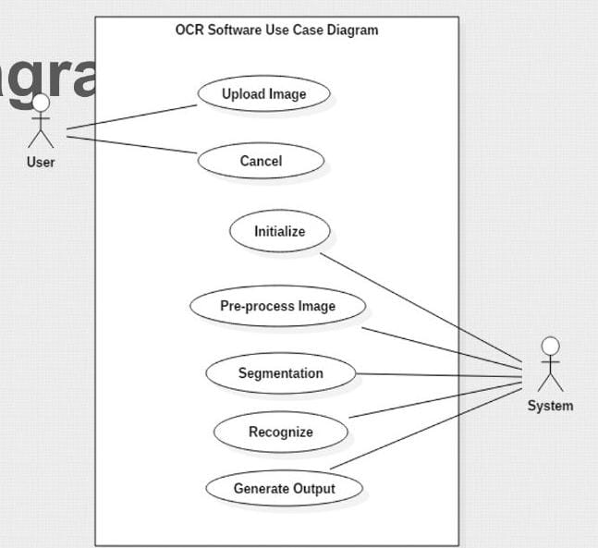

1. Upload valid image
2. Cancel
3. Crop image
4. Process image
5. Detect character
6. Recognize character
7. Generate output

**- The Dataset employed is**

# **EMNIST (Extended MNIST)**

The EMNIST dataset is a set of handwritten character digits derived from the NIST Special Database 19 and converted to a 28x28 pixel image format and dataset structure that directly matches the MNIST dataset.

**We will use by merge dataset**

**Merge dataset is** an uneven number of images per class and there are more digits than letters. The number of letters roughly equate to the frequency of use in the English language.

By using merge dataset we reduce mis-classification errors due to capital and lower case letters and also has an equal number of samples per class. This dataset is meant to be the most applicable.

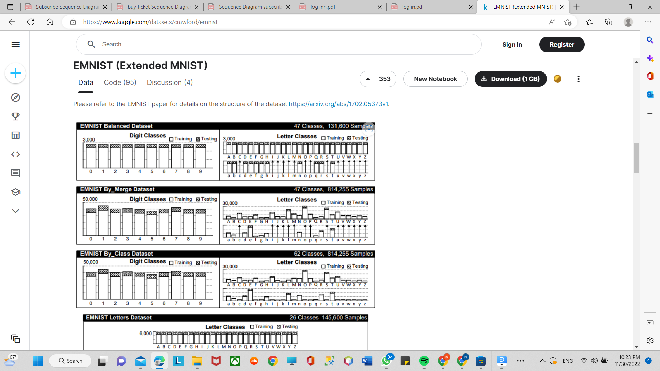

**-The EMNIST Letters dataset merges a balanced set of the uppercase and lowercase letters into a single 26-class task**

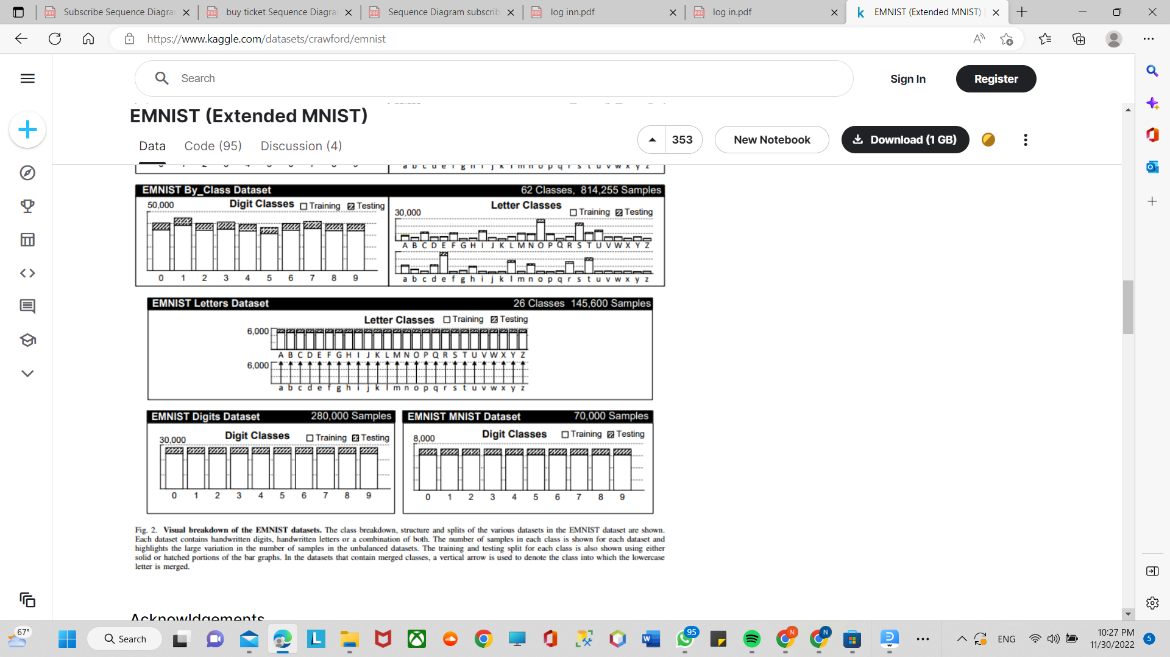

-**The EMNIST Digits and EMNIST MNIST dataset provide balanced handwritten digit datasets directly compatible with the original MNIST dataset.**

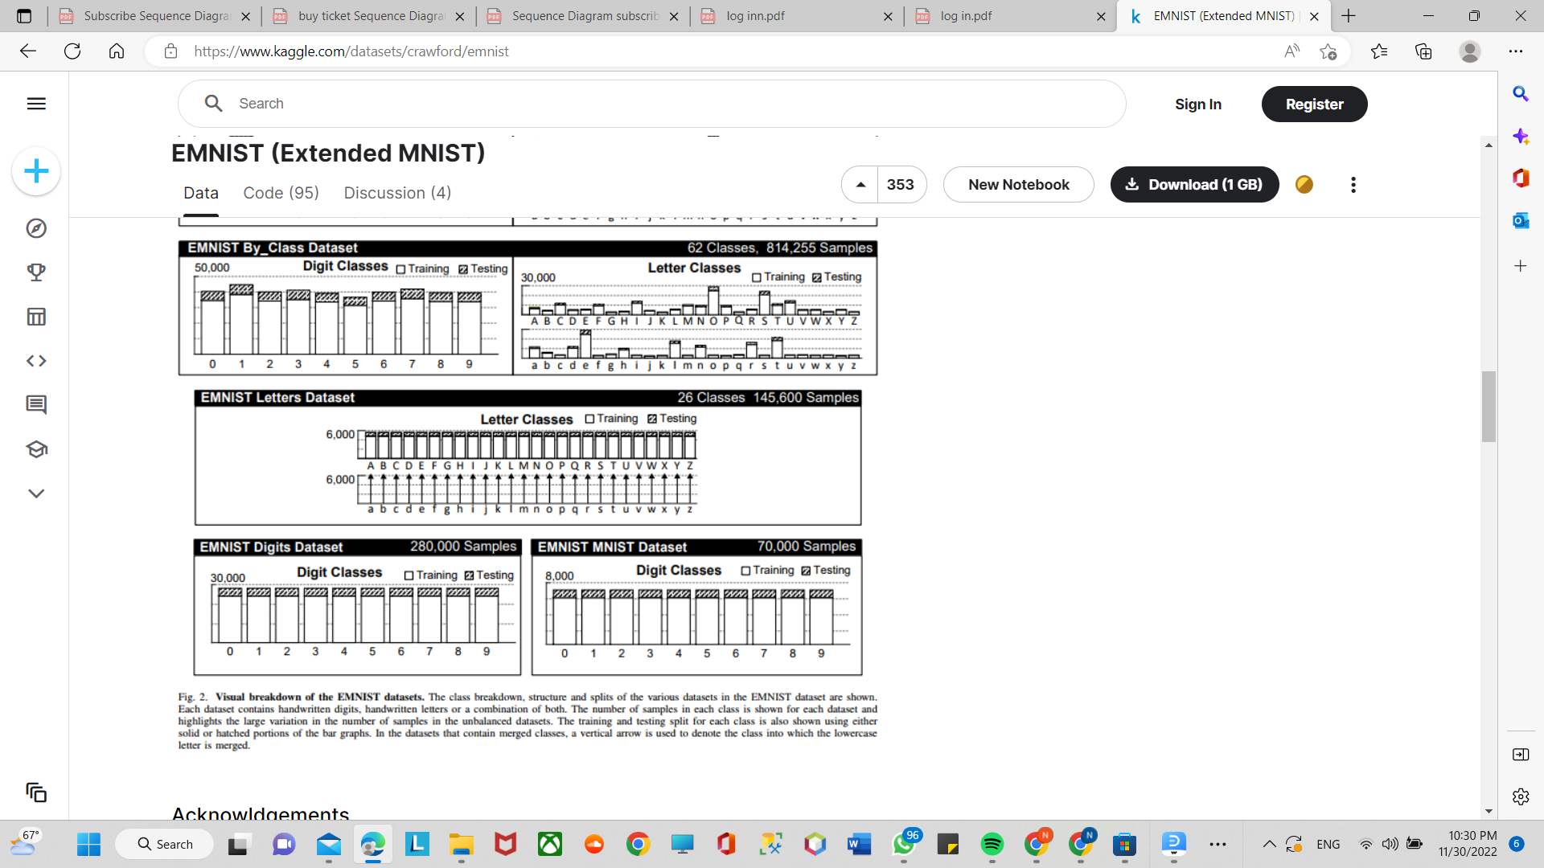

***Similar applications in the market.***

As the name suggests, the handwritten Character recognition is the ability of computers to recognize human handwritten characters. Or in easy words we can say that it is the ability of computers to detect the character present in a particular image and recognize that character.

### About Handwritten Character Recognition Project:

This is Deep learning project, or we say Machine learning project in which we will create a Convolutional neural network(CNN) model with the help of tensorflow and keras which will recognise Handwritten characters, i.e English alphabets from A-Z. The dataset on which we will train our model contains a large number of images of English alphabets.

For image recognition and processing, there is a very popular artificial neural network used that is Convolutional neural network (CNN) that is specifically designed to process pixel data. And that’s why we are going to build a CNN model to recognise character.

I hope you understand what we are going to build and what the project is all about. Without wasting any time further let’s directly dive into the implementation of this Handwritten Character Recognition using Tensorflow Project by ProjectGurukul.

( <https://data-flair.training/blogs/handwritten-character-recognition-neural-network/> **)**

**3. Applied Algorithms**

***Block diagram***

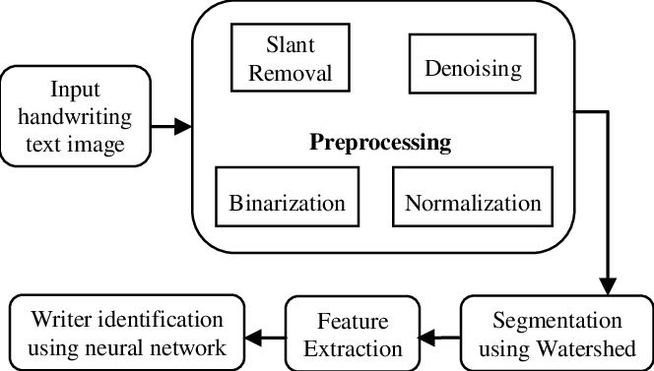

***Flow chart***

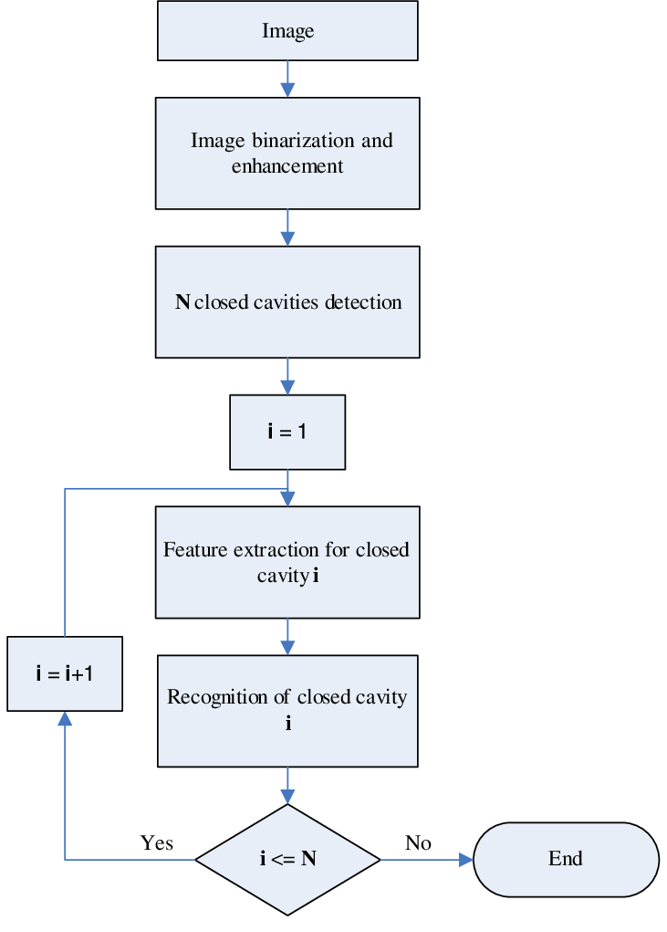

**-What is a neural network?**

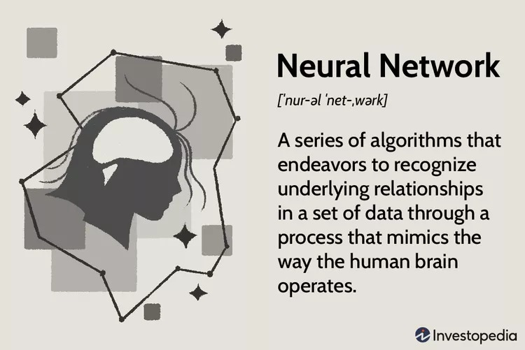

A neural network is a method in artificial intelligence that teaches computers to process data in a way that is inspired by the human brain. It is a type of machine learning process, called deep learning, that uses interconnected nodes or neurons in a layered structure that resembles the human brain. It creates an adaptive system that computers use to learn from their mistakes and improve continuously. Thus, artificial neural networks attempt to solve complicated problems, like summarizing documents or recognizing faces, with greater accuracy.

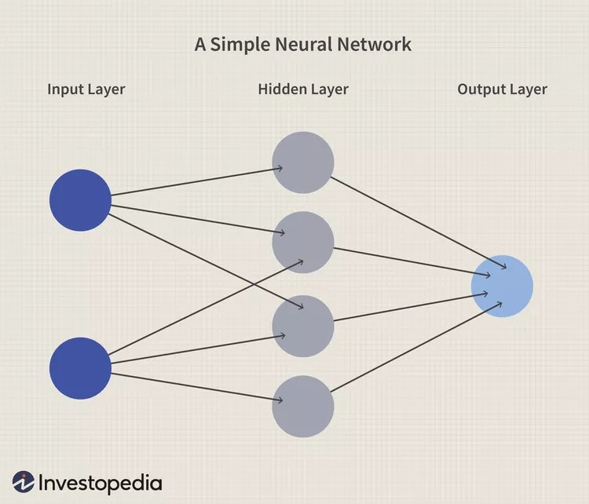

A basic neural network has interconnected artificial neurons in three layers:

**Input Layer**

Information from the outside world enters the artificial neural network from the input layer. Input nodes process the data, analyze or categorize it, and pass it on to the next layer.

**Hidden Layer**

Hidden layers take their input from the input layer or other hidden layers. Artificial neural networks can have a large number of hidden layers. Each hidden layer analyzes the output from the previous layer, processes it further, and passes it on to the next layer.

**Output Layer**

The output layer gives the final result of all the data processing by the artificial neural network. It can have single or multiple nodes. For instance, if we have a binary (yes/no) classification problem, the output layer will have one output node, which will give the result as 1 or 0. However, if we have a multi-class classification problem, the output layer might consist of more than one output node.

**Neural Networks**

Pros

* Can often work more efficiently and for longer than humans
* Can be programmed to learn from prior outcomes to strive to make smarter future calculations
* Often leverage online services that reduce (but do not eliminate) systematic risk
* Are continually being expanded in new fields with more difficult problems

Cons

* Still rely on hardware that may require labor and expertise to maintain
* May take long periods of time to develop the code and algorithms
* May be difficult to assess errors or adaptions to the assumptions if the system is self-learning but lacks transparency
* Usually report an estimated range or estimated amount that may not actualize

**-How to train neural networks?**

Neural network training is the process of teaching a neural network to perform a task. Neural networks learn by initially processing several large sets of labeled or unlabeled data. By using these examples, they can then process unknown inputs more accurately.

**Supervised learning**

In supervised learning, data scientists give artificial neural networks labeled datasets that provide the right answer in advance. For example, a deep learning network training in facial recognition initially processes hundreds of thousands of images of human faces, with various terms related to ethnic origin, country, or emotion describing each image.

The neural network slowly builds knowledge from these datasets, which provide the right answer in advance. After the network has been trained, it starts making guesses about the ethnic origin or emotion of a new image of a human face that it has never processed before.

## **Types of Neural Networks**

### Feed-Forward Neural Networks

Feed-forward neural networks are one of the more simple types of neural networks. It conveys information in one direction through input nodes; this information continues to be processed in this single direction until it reaches the output mode. Feed-forward neural networks may have hidden layers for functionality, and this type of most often used for facial recognition technologies.

### Recurrent Neural Networks

A more complex type of neural network, recurrent neural networks take the output of a processing node and transmit the information back into the network. This results in theoretical "learning" and improvement of the network. Each node stores historical processes, and these historical processes are reused in the future during processing.

This becomes especially critical for networks in which the prediction is incorrect; the system will attempt to learn  why the correct outcome occurred and adjust accordingly. This type of neural network is often used in text-to-speech applications.

### Convolutional Neural Networks

Convolutional neural networks, also called ConvNets or CNNs, have several layers in which data is sorted into categories. These networks have an input layer, an output layer, and a hidden multitude of convolutional layers in between. The layers create feature maps that record areas of an image that are broken down further until they generate valuable outputs. These layers can be pooled or entirely connected, and these networks are especially beneficial for image recognition applications.

### Deconvolutional Neural Networks

Deconvolutional neural networks simply work in reverse of convolutional neural networks. The application of the network is to detect items that might have been recognized as important under a convolutional neural network. These items would likely have been discarded during the convolutional neural network execution process. This type of neural network is also widely used for image analysis or processing.

### Modular Neural Networks

Modular neural networks contain several networks that work independently from one another. These networks do not interact with each other during an analysis process. Instead, these processes are done to allow complex, elaborate computing processes to be done more efficiently. Similar to other modular industries such as modular real state , the goal of the network independence is to have each module responsible for a particular part of an overall bigger picture.

**8 Applications of Neural Networks**

* Artificial Neural Network (ANN)
* Facial Recognition.
* Stock Market Prediction.
* Social Media.
* Aerospace.
* Defence.
* Healthcare.
* Signature Verification and Handwriting Analysis.